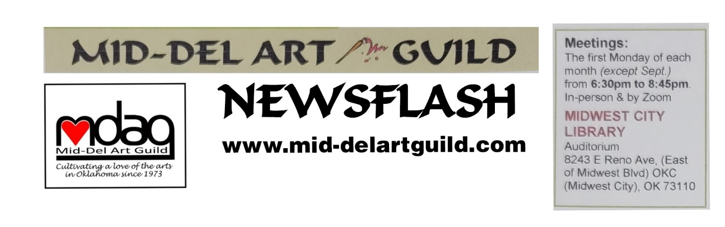

August 2023 Newsflash

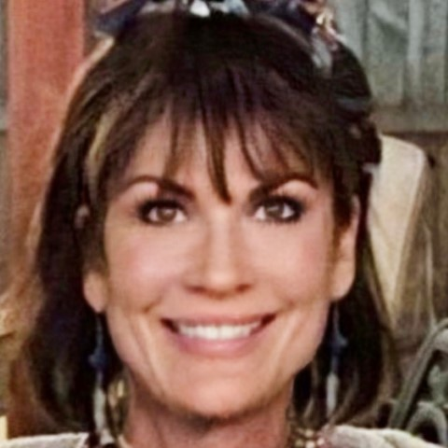

Lisa Lampton Allen
Teaching Painting Techniques with Trowel and Layering
Demo August 7 at 6:30pm MWC Library Forum Auditorium
Workshop August 12 at Hideout Art

Lisa Lampton Allen is the owner of Hideout Art, the partying art studio located in the revamped Historic Britton District at 911 West Britton Road, Oklahoma City (phone 405-760-0683). For five years Lisa has hosted numerous corporate trainings, private lessons, birthday parties, anniversary parties, in fact all kinds of parties at her studio. Be wowed. You will get to see her upbeat, fun, energized approach to painting “Outside the Lines” as she drags color in various ways to create more abstract modern pieces. Lisa is very good at fielding questions as evident when she presented a demonstration for the Oklahoma Art Guild earlier this year and not only enticed Susan Schmidt to invite her to be a demo artist for the MDAG but was the inspiration for Susan’s demo for the Tiny Homes project.
Learned from years of traveling around the country to headline corporate retreats, Lisa keeps the dialogue going as she involves the audience in the painting process. Ask her questions about her business initiatives like the art camp for kids she offered this summer. Or about the OSU intern she hired to help run the parties and camps. How about how to incorporate friendships into your business plans (the intern, Elizabeth Sanders, is the daughter of her artist friend who has an art studio in Edmond. And the coffee shop next to Lisa’s studio is owned and managed by another friend. If you have been to Lisa’s studio where the MDAG schedules its workshops, you may have gone into the back patio area. It is delightful and there is a gate they can open between the businesses.

The following is a painting by Lisa Lampton Allen

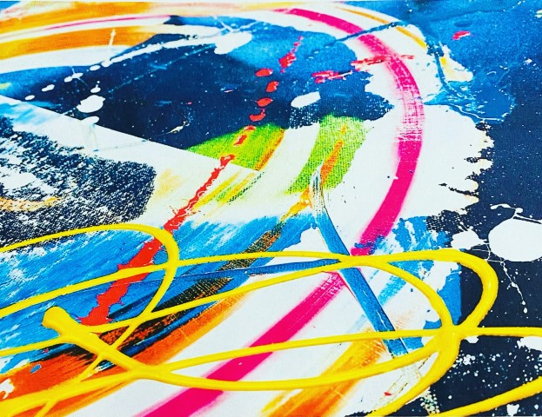

Looking Ahead…
October 2 – Polly Sharp - Demo “Plein Air How To. Equipment Pros & Cons with Demo in Oils
October 14 – Polly Sharp – Workshop – Plein Air Painting at Will Rogers Park (date change avoids OU/TX game.)
November 6 – Jerry Piper - Demo "Back with Exciting Opportunities"
TBD – Jerry Piper - Workshop
December 4 – Holiday Party - Restaurant TBD
January 8, 2024 – Artist - TBD

REMEMBER WE WILL BE VOTING ON BYLAWS CHANGES at AUGUST 7 MEETING.

Thank You Sarah Atlee
Improvisational quilter Sarah Atlee was a professional painter for many years until she experienced a chronic illness with multiple hospitalizations and realized she experienced more joy when quilting than when painting.
After her last obligation to show her paintings in a gallery in 2016 she switched to focus full time on quilting. The feel of the hospital gown she was sent home with, extra soft from repeated washings, was a reminder of her parents’ hippy days where they didn’t allow waste and made quilts from used clothing. She incorporated that hospital gown in a quilt she made for herself. Quilting was no longer the hobby she started when she graduated from high school and made a quilt for college. Quilting became her passion and recognition that joy, satisfaction in what you do with your time can improve your health. Sarah offered the following tips for living with chronic illness:
1. Know you are not alone.
2. Listen to your body.
3. Read the book ChronicBab 101: How to Craft an Incredible Life Beyond Illness by Jinni Grover.
Like the hospital gown, Sarah has found that used clothing of different materials, colors and patterns, that has been washed repeatedly makes good quilts that also wash well. Friends donate fabric, plus Sarah is a regular at thrift stores where she suggests you shop for men’s extra large cotton shirts. The backs of XL shirts provide quite a bit of fabric. And sheets make good bottom layers.
Some of her quilts have a theme like stripes or incorporating working pockets into the quilts. When she makes pot holders, she uses a technique called “quilt as you go” where you build one piece at a time and sew it to the batting. One of the two layers of batting includes a special fleece with a heat resistant mylar-like component. Missouri Star Quilt Company has excellent YouTube videos on the "quilt as you go" process.
Sarah led a lively discussion with the audience during the demo and during the break. Marilyn Ragan said she has made quilts for years which she donates. In fact, Marilyn donated a small quilt as a door prize at the July 10th meeting along with other freebies Kara Gardner and Cindy Van Kley made available.
For people who have made quilts or have quilt tops but have not had the layers sewn together yet, Marilyn passed on news she heard that in addition to a 3-D printer, the Downtown OKC Metro Library also has a long arm quilter that people can use to learn how to machine quilt their layers together. The larger quilts are made differently than the pot holders and are sewn together by hand or machine quilting. Quilting is an ancient process which remains popular today.
Sarah’s slideshow included copies of her quilts, history of quilting, and myths about quilting. She mentioned a quilting organization that has over 17,000 member groups (that is groups not members) around the world. Which explains the question: How are quilters like cockroaches? “We are everywhere”.
Congrats to the Winners
First Place – DeAun Olive “Floral Explosion”
Second Place – Sandra Patterson “Peach Harvest” from her peach tree.
Third Place and Judges Choice – Isabella Campos “Sunflowers”

Tiny Homes Paintings Delivered

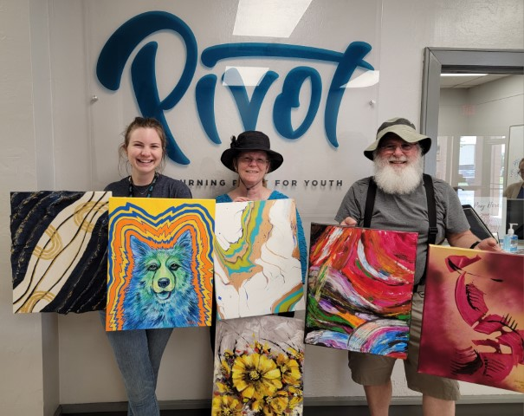

On June 30th Bill and Susan Schmidt delivered the 48 paintings MDAG members created and donated to Pivot for display in their Tiny Homes for Teens. The following message was included on the back of each painting…”We in the Mid-Del Art Guild wish you the courage to face adversity, the wisdom to learn from every experience and the joy of discovering the beauty that art and life offers. June 2023”. Pivot staff were very complimentary and grateful. Thank you for participating in this worthwhile project to support the community and next generation. We each need a helping hand at times and we have the opportunity to grow personally when we reach out and help others.

“Call to Action”

The MDAG board wants to extend our deepest gratitude for your ongoing support and enthusiasm. Each of you plays a critical role in the success of our club, and for that, we are grateful. We have an opportunity to grow and continue our shared mission of fostering an appreciation for art, improving our art skills and engaging the community. That takes a willingness to continually learn and collaborate.
It is time to nominate officers who will carry MDAG over the next year. We understand that times have changed significantly over the last few years, but we believe our shared passion for art has the power to enrich our lives and the lives of others.
Whether you've been with the guild for years or just recently joined, your membership and commitment are invaluable. If you know others who may be interested in joining us, please extend an invitation to them. Talk us up on social media and in-person. Remember, our strength lies in our numbers, diversity, and collective passions.
Volunteerism is at the heart of our club. For those who have given their time and energy to our club's initiatives, we want to extend our heartfelt thanks. Many of you have worked for years such as Cindy Van Kley. Madeline Dillner, and Jane Morgan as president, Madeline as our webmaster, Cindy as newsletter editor, Sandra Patterson and Joan Faught for managing Hanging Around Town, Karen Dickerson for providing both attractive and delightful refreshments at our meetings, and Kara Gardner for keeping our finances in order. And the many others of you who were not named. We thank you all.

We cannot overstate the impact that volunteers make to MDAG. Volunteering allows us to offer events and share skills and knowledge with fellow members. Learning and perfecting the duties required to perform those positions will result in the volunteer’s personal growth and members enrichment from our combined efforts. If you are interested in volunteering or know someone who might be, please reach out. Call Kara Gardner at 405-317-7655. There is always room for more helping hands. Kara has gotten some commitments which the board is grateful for, but there are still a few more positions which need to be filled.
Positions that need to be filled with basic duty includes:
President – Conduct the meetings and lead MDAG.
First Vice President –Arrange demo artists and workshops.
Second Vice President - Arrange opportunities for members to enter shows and exhibits.
Secretary – Keep records of guild meetings.
Treasurer – Pay bills and ensure finances are in order. Kara Gardner agreed to continue as Treasurer.
Member-At-Large – Represent members on the board.
Parliamentarian – Ensure business meetings follows Roberts Rules of Order and ensure a new slate of officers are nominated.
Appointed positions (at this time) include newsletter editor, hospitality, greeter, Hang Around Town, and webmaster. Karen Dickerson agreed to continue as Refreshment Chair. The greeter needs to be in position to welcome visitors and members at 6:15pm before the meetings. The newsletter is being redesigned to be less burdensome to write. The MDAG Newsflash sent directly in email (normally without attachments) will be much easier to format and require less content.
Perhaps some of you want to share duties to fit around your other obligations or plans. Grow personally as you help the guild grow.

CURRENT OFFICERS
PRESIDENT:................... Cindy Van Kley
1ST VICE - SPECIAL EVENTS: Susan Schmidt
2nd VICE – PROGRAMS: Susan Schmidt
SECRETARY:............. Suzanne Henthorn
TREASURER:.................... Kara Gardner
MEMBER AT LARGE:........ Jude Delaney
MEMBER AT LARGE: Elizabeth Painchaud
PARLIAMENTARIAN:................... Vacant

APPOINTED POSITIONS
NEWSLETTER:........... Susan Schmidt
HOSPITALITY:.............. Karen Dickerson
GREETER:...................... Mojgan Busick
GREETER:.............. Elizabeth Painchaud
HANG AROUND TOWN Joan Faught
WEBMASTER: Arelia Rocker

File: art/MDAG/Newsletters/2023 August MDAG Newsflash as of 122223

