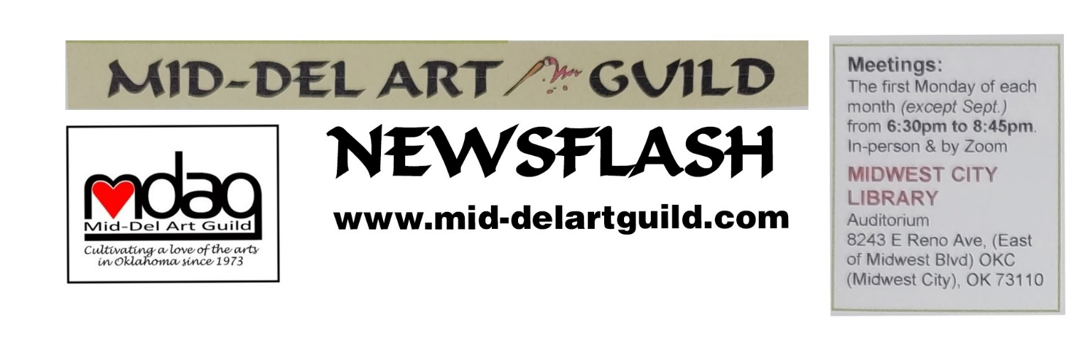September 2023 Newsflash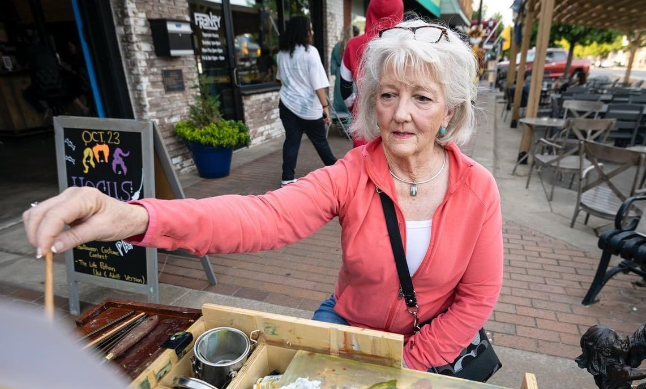
POLLY SHARP
Guest Artist Demo Monday Oct 2, 2023 at MWC Library
Workshop Saturday Oct 14 at Will Rogers Gardens
Our guest artist for October’s MDAG meeting is Polly Sharp, a Plein Air Impressionist Landscapes artist who paints on canvas. Her artist statement was a delightful introduction so in her words…
“It’s all about the light! As a plein air oil painter it is always the light that I look for. It is my inspiration as I explore the awesome landscape.
Every beautiful scene I try to capture in oil on my canvas is a new wonder to me. I am constantly aware of my Cherokee Nation ancestors while trying to paint the land they walked and enjoyed in its natural beauty. Gathering up my always loaded and ready backpack and easel, I go out often to find one of Oklahoma’s exploding sunrises, wandering rivers or creeks, rolling hills, or flashing sunsets. Before starting a painting, I observe a sense of place: the sounds of birds, the lapping water, the breeze, the smell of wildflowers. All these things figure into the character of the painting.
Often, I set out to paint a spot I have seen, but never get there, struck by the beauty along the way. Hours can go by, even forgetting to eat while painting, if the light is just right and the painting going well.
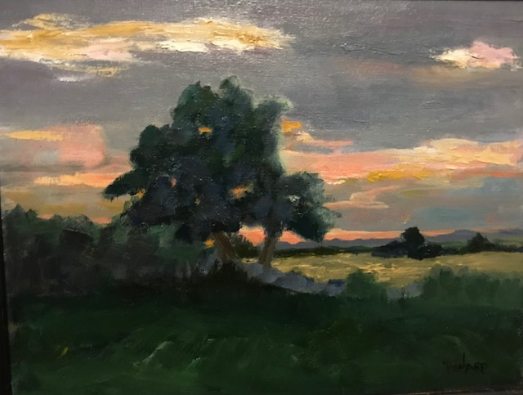
Plein Air Landscapes in Oil. That’s my jam! Still life painting in the studio is just that to me. Still. Dead. Static and manipulated. Out in our Creator’s countryside the scene has already been laid out before me with perfect light, color harmony, shadows, and composition. It is always a challenge to try and capture the amazing beauty of God’s creation.
Polly has lived her entire life in Oklahoma. Her paternal great grandmother made the Trail of Tears journey to Oklahoma from Georgia. Her maternal grandparents, originally from Ireland, made the land run. Polly loves the outdoor beauty that is Oklahoma with its rolling hills and prairies, soaring cloudscapes, flaming sunsets, and wandering creeks and rivers. She always keeps her gear ready and loaded, often rising early to catch the morning light. Polly will bring her gear and share what she considers essential supplies and equipment to help us paint in the outdoors.
The workshop will be held Saturday October 14 from 9 am to Noon at Will Rogers Gardens in OKC. Meeting at 9am will allow our paintings to capture the morning light. Join the group in the parking lot on the south side of the exhibition building at 3400 NW 36th Street. The parking lot is next to the pond and can be reached from the frontage road on the west side of I44. There should still be flowers blooming in October and there is plenty of space to spread out to find the perfect landscape. You need not paint in oils. Any medium will work. The cost for the workshop is $40 for MDAG members and $50 for non-members. Please sign up and pay at the October 2nd meeting. If you can't make the demo and want to attend the workshop, call Kara Gardner at 405-317-7655. The demo is free to members, guests, and potential members.
Polly has been painting plein air about 10 years. She is a self-taught artist, taking studio lessons, workshops, and on-line studies. It was only after retirement and her girls were grown that she was able to follow her passion in earnest. She has studied and taken workshops from Cletus Smith, Rick McClure, Phil Starke, Kelli Folsom, Scott Christensen, and Skip Whitcomb.
Polly’s works have won numerous awards and been featured in many locations. Current works are shown at Rusty Gables Gallery, Oklahoma City; the lobby of Jet Set Pro at Wiley Post Airport; and in her home studio in Edmond, Oklahoma. Polly can be reached at 918-231-9090 or email: pollysharp@att.net. WEBSITE: www.pollysharpfineart.com.
Thank You Lisa Lampton Allen
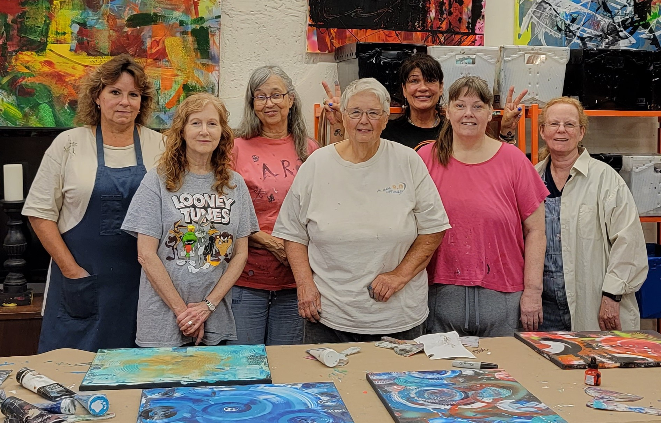
The workshop with Lisa on August 12 was a blast. We used trowels, spray paint, acrylic and other supplies and tools. We started with our choice of black or white canvas. Everything we needed was supplied: we didn’t even need to bring our brushes. Look Ma, No Brushes Needed! There were lots of trowels to pick from. And there was so much paint the colors were in colored bins. Reach for and take some. No tiny dab of paint like at most paint parties. The workshop was so much fun. Keep in mind that if you register and pay for a class and for whatever reason you cannot attend, send a substitute. Lisa’s studio at Hideout Art allowed us to spray paint outside and she had stencils too, all of which added to the multi layered excitement.
Bylaws Update
The bylaws were approved unanimously by the 19 MDAG members present at the August 7th meeting. Susan Schmidt incorporated the changes, some of which have been in limbo since before 2019, and distributed the attached to the board to check for errors. No corrections were noted and the bylaws are attached for your review. If no corrections are brought up at the October 2 meeting, the bylaws will be released for posting on the website. Amendments, such as to add the Parliamentarian back as a voting member, can be made at any regular meeting by 2/3 vote of the members, provided that notice of the proposed amendment shall have been given at the previous meeting.
Winners From August 7
The member contest winners were: 1st place Sandra Patterson for “Cabin by the Lake”, 2nd place was Nan Trosper for “Waterfall”, and 3rd place and Judges Choice was June Rea for “Beginning of Fall. Congrats!
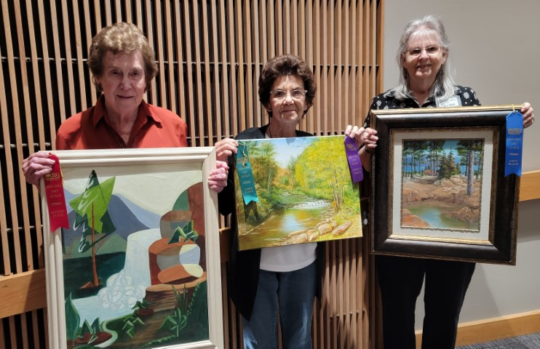
Midwest City Elementary Mural Project
The school counselor and art teacher at Midwest City Elementary (MCE) school requested MDAG paint a mural on a 24 foot by 8’4” wall in the cafeteria stage. MCE is a Title 1 school with 100% of their students on Free and Reduced Lunch. Although it is an elementary school, the children are exposed to many life situations that rival that of high school so the school would like the artwork to be more of what is appropriate for middle school/high school level. The focus of the mural could include jet or bomber aircraft (The Jets is their mascot), diversity, inclusion, and community or something else as no decisions have as yet been made. “A powerful quote/statement” could be incorporated in the design. Plus, they do want the mural to be painted with bright colors. The school has the funds to pay for supplies and tools but not for labor, so we are looking for volunteers to help. Cindy plans to have a committee of interested members meet with the school and maybe some students on Monday September 11 from 9 to 10 am. If you would like to participate, call Cindy Van Kley at 405-630-4504.

SCHEDULED EVENTS.
October 2 – Polly Sharp - Demo “Plein Air How To. Equipment Pros & Cons with Demo in Oils
October 14 – Polly Sharp – Workshop – Plein Air Painting at Will Rogers Park
November 6 – Jerry Piper - Demo "Back with Exciting Opportunities"
TBD – Jerry Piper - Workshop
December 4 – Holiday Party - Restaurant Olive Garden at 5915 SE 15th St, MWC
January 8 – Demo TBD
January 13 – Workshop TBD

Hope to see you October 2 at the MWC Library.
Susan Schmidt, Newsletter Editor

