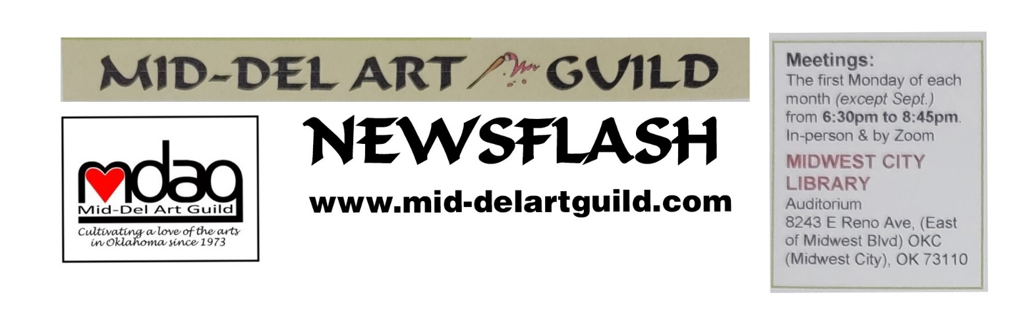October 2023 Newsflash
JERRY PIPER
Guest Artist Demo 6:30 pm Monday Nov 6, 2023 at MWC Library
Jerry will not offer a workshop.
Our guest artist for November’s MDAG meeting is Jerry Piper. Jerry is an Oklahoma artist and previous 2nd VP for MDAG and is responsible for many enjoyable programs in the past few years, including the panel where we got better acquainted with other MDAG members.
Originally from Illinois, Jerry has lived over 30 years in Oklahoma and calls it home. He was educated in art at Eastern Illinois University and studied with such notable professors as Yu Ji, Walter Sorge, and Kit Morrice. In Oklahoma he has been mentored by Cletus Smith.
Jerry works in various media as oil, watercolor, acrylic, mixed media and pastel. His paintings have taken Best of Show, and he was awarded at the annual Art, Wine & Music Festival in Guthrie. Jerry’s work has been featured in various galleries in the Midwest, including The Purple Loft, 50 Penn, Paseo Artworks, and currently represented by The North Gallery & Studios.
The North Gallery & Studio has been voted in the Top 3 for “Best Art Gallery” by the Oklahoma Reader’ Choice Awards. Jerry will be sharing an opportunity for MDAG members to showcase their for-sale works for a month in 2024 at the gallery. Details regarding the juried show for MDAG will be determined later.
Jerry has been a highly sought instructor in different media and has taught K-12 in private schools, and adjunct faculty at Rose State College, and adult art classes at the Healthy Living Center OKC.

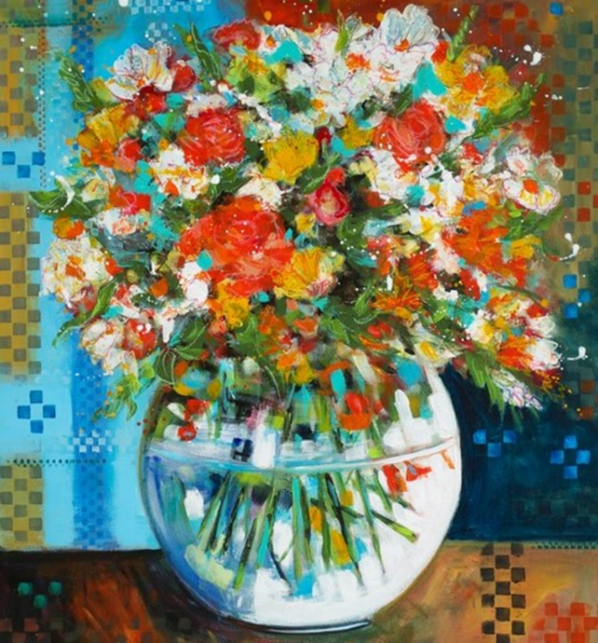
Jerry will use acrylic, possibly mixed media, in the November 6th demo. The subject will be floral with the emphasis on how to define a clear glass vase. A lot of people have asked Jerry about that and some of his award-winning work has incorporated glass. He will also hold a drawing for one of his prints of florals in a glass vase during the demo. So don’t miss your chance to win!
Polly’s Workshop October 14

Space is still available for the Plein Air Workshop with POLLY SHARP 8:45 am to Noon Saturday Oct 14th. Meet in parking lot by the Pond at Will Rogers Park. Just show up. Polly prefers painting in oils and can give the most help in oils. You can bring your medium of choice. Pay Polly directly, $40 for members or $50 for guests.
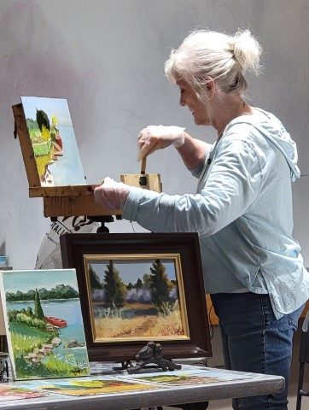
Thank You Polly Sharp
By Susan Schmidt
Polly began her talk about her miraculous comeback from a massive stoke two and a half years ago. Unable to walk or talk. She was in Jim Thorp for 30 days. When she asked if she would paint again and be able to carry her 20-pound backpack the experts said “it won’t happen.” Polly partially attributes fact that she was a healthy eater and in good physical shape before the stroke with her recovery. And she was determined to paint again. Her family brought her painting gear to the hospital and she began to paint in her room. Then she convinced her therapists to help her walk around the halls with her pack on her back. The therapist played music to improve her gait and followed close behind in case she needed help. She admits her physical therapy five times a day was hard.
Polly was determined to paint outdoors, without a wheel chair! Her Jim Thorp therapists were amazing the way they worked with her. They even took her by van to Will Rogers Park to paint. That is the same park where she is holding her workshop. You can participate Saturday, October 14th. Just show up and pay. Polly’s experience was a truly an inspirational reminder to not give up. None of us know what challenges we will face and it is helpful to witness how others overcame the challenges we may face. When I was 20, I watched a man with no hands, just hooks, pack his own parachute for skydiving. Because of his example, I always knew I could cope with losing a limb. As I aged that memory made me more resilient.
The October 2 demo covered the equipment and supplies Polly recommends for painting in oils outdoors. She was extremely well prepared and shared a four-page step-by-step info sheet with the 25 people in attendance. The sheet included descriptions of easel boxes (Pochade) with prices. She showed the Sienna Plein-Air box which is small enough to carry in her backpack. Unloading the Swiss backpack gave the audience ideas on worthwhile things to carry which this editor took extensive notes on, very helpful.
During the break, we were treated to Halloween goodies. Karen decorated the table. Nan Trosper and her granddaughter Bella made spiders, and other holiday snacks.
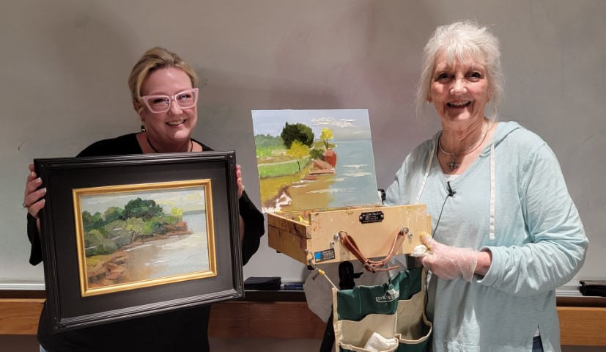
Polly (pictured with her daughter Andy) painted a scene from Arcadia Lake using a Guerilla Box on a tripod which she prefers for shorter trips when she wants to keep it simple. To further reduce the weight of supplies in the field, Polly often limits the paint to 6 tubes of cool and warm colors plus Titanium White: Cad Yellow/Lemon Yellow, Cad Red/Alizron Crimson, and Ultramarine Blue/Cerelean. Sometimes she adds earth color modifiers Yellow Ochre, Burnt Sienna, and Burnt Umber and other colors once back in the studio. If you missed the demo, you can catch parts on MDAG’s Facebook page, but it is not near the same as seeing the demo in person. For instance, you could miss her many hints like bodies of water are always darker than the sky. Thank you Marilyn Ragan for taking and posting the video clips. Polly’s demo was an example of the generosity of artists sharing what they have spent decades learning.
Election of Board and Appointed Positions: At the member meeting, Cindy and Kara stressed the importance of members filling positions to keep MDAG alive. Polly Sharp added that MDAG is regarded as the best guild with a long history that should not be allowed to lapse. Members volunteered. With the exception of Newsletter editor, the slate for 2024 is complete. MDAG members unanimously voted October 2 to elect the following six officers and welcomed the appointed positions.
Executive Board (Voting Positions):
President – Joan Faught
1st VP Shows – Marilyn Ragam
2st VP Programs – Susan Schmidt
Treasurer – Kara Gardner
Secretary – Cindy Van Kley
Member at Large - Mary Jude Delaney

Appointed Positions:
Parliamentarian – Cindy Van Kley
Hospitality – Karen Dickerson
Hang Around town – Sandra Patterson
Greeter – Dana Masters
Webmaster – Arelia Rocker
Social Media - Marilyn Ragan
Newsletter – Vacant [Susan Schmidt can continue until someone volunteers to be Co-editor or take over].
The elected officers should decide who they want to name as their proxy and tell the secretary at the November meeting. Naming a proxy is allowed by the bylaws so business can continue when officers are absent and it is a way to give future officers experience. If those of us with duties are going to miss a meeting, we always want to make sure our positions are covered. 2024 is a good year to take someone under your wing and train them on your job. As Cindy said, each of us have never held a certain job until we did! We learn as we go but a bit of help is sure appreciated. Anyone with journalism background or love to write? Susan Schmidt is willing to help a volunteer write portions of the newsletter and feed info to Arelia for the website and Marilyn for social media.
Bylaws Update

Because the bylaws were amended in August, members get the last three-months of 2023 dues-free as the new year officially will start January 2024. Membership dues remain $35 and are due before January. No corrections to bylaws were offered from the floor. An application form is attached.
October 2 Winners
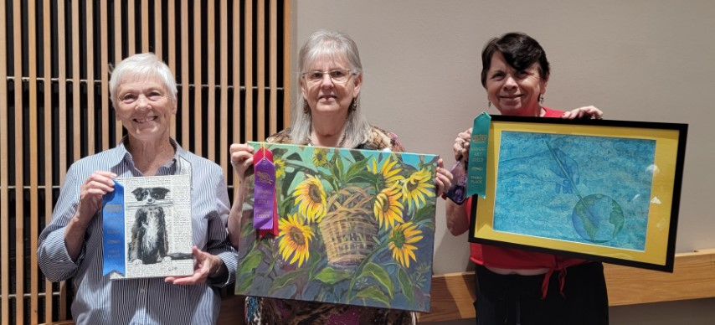
The member contest winners were: 1st place Cheryl Hudson for “Extra Extra” in acrylic, 2nd place and Judges Choice was Sandra Patterson for “Sunflowers” in acrylic, and 3rd place was Marilyn Ragan for “Paint the World with Color” with water color. Congrats!

Show Opportunities

There will be a show of all the 2023 winners at the MWC Library from January 2 through 31. You can hang your winning pieces and/or other works to fill-in. Set-up on Tuesday, January 2 from three to 5pm would allow the most coordination among artists for space with the last artists making final adjustments to make the space look good. Marilyn Ragan is the 2024 First VP and is in charge of shows.

All members of MDAG are invited to reserve the library wall for an individual or group show. As of this writing, the wall and presumably cases are available from November 2023 through December 2024. Drop into the MWC Library to make a reservation or call 405-606-3436.
Midwest City Elementary School Mural Project

The school counselor and art teacher at Midwest City Elementary (MCE) school requested MDAG paint a mural on a 24 foot by 8’4” wall in the cafeteria stage. The kids and staff voted on an inspirational quote to aid in the design. The winning quote is "You are loved and important, you bring to this world what no one else can.” If you would like to volunteer to help paint, save the dates October 20 thru 23, when the kids will be out of school. The school address is 2211 Midwest Blvd, MWC 73110. You may need to knock on the cafeteria outside door for one of us to let you in. Our cars will be parked close by. Wouldn’t it be neat if we made a timelapse short video of the mural as it progressed from white wall to finished mural? If you would like to participate or confirm work hours, call Cindy Van Kley at 405-630-4504.
SCHEDULED EVENTS
November 6 – Jerry Piper - Demo "Glass Bowl with Flowers"
December 4 – Holiday Party - Restaurant Olive Garden at 5915 SE 15th St, MWC
January 2 thru 31 – 2023 MDAG Winners Exhibit – MWC Library Wall
January 8 – Lyuda Cameron Demo - “Painting for Peace”
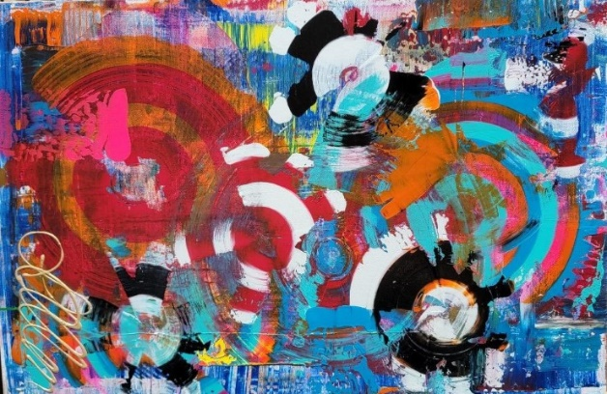
January 13 – Lyuda Cameron Workshop - “Painting for Peace” at Wickline United Methodist Church. MWC
February 5 – Jane Morgan Demo - “Get Your Paintings Critiqued” (Everyone, bring paintings you think need help)

Holiday Party and Raffle. A raffle started October 2 will be drawn at the Holiday Party December 4th. One winner will receive the large abstract painting Lisa Lampton Allen painted in her demo. Plus, there will be other goodies Kara Gardner is arranging. This is a fundraiser. Bring your money to the Nov 6 meeting and December 4 party, $5 for one ticket or 4 for $20.
Join Mid-Del Art Guild
Membership
type: q Single/$35 q Student*/$20 q Family**/$40 q Business/$40
qNew
qRenewal Referred by:____________________________________________________

Date:_________________ Favorite Medium(s):________________________________

Name(s): __________________________________________________________________

Address___________________________________________________________________

City_______________________________ State_______ Zip________________________

PHONE: Home__________________________ Cell______________________________

E-Mail (for newsletter) _______________________________________________________
*Must be enrolled full time as Art Major, with current Student ID, or aged under 19 yrs old
**Two family members residing in the same household

Make checks payable to: Mid-Del Art Guild
Mail to: Kara Gardner, Treas. • PO Box 10393 • Midwest City, OK 73140

Hope to see you November 6 at the MWC Library.
Susan Schmidt, Newsletter Editor

