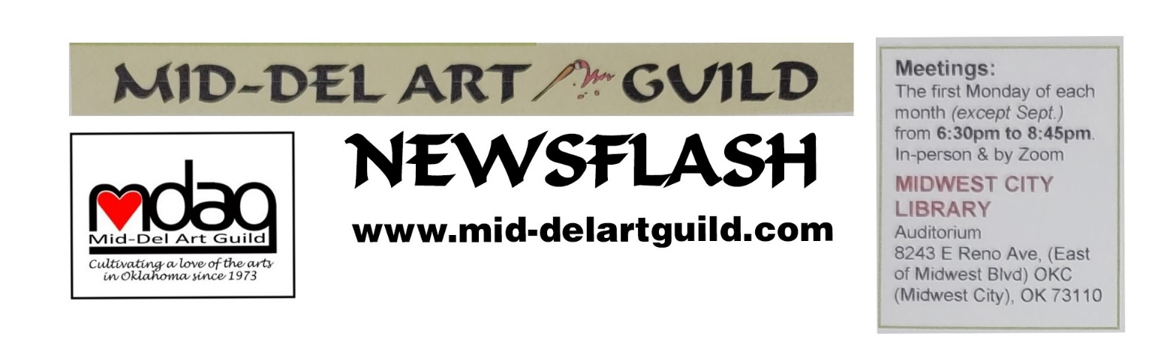November/December 2023 Newsflash

Holiday Party at Olive Garden Dec 4 at 6pm

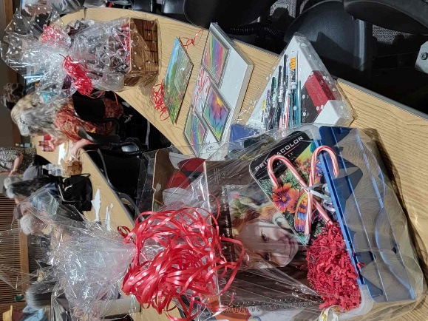
Karen Dickerson invites all MDAG members and their guests to attend the holiday party at the Olive Garden, 5915 SE 15th Street, MWC on December 4 at 6pm. Fifteen members have already signed up. Pay for your dinner and bring extra money to purchase raffle tickets for the marvelous raffle items Kara Gardner obtained (she purchased a lot of the items). Some of the baskets have over $100 worth of brushes alone plus other art supplies for water color, colored pencils, etc! And Lisa Lampton Allen’s large abstract painting she demoed last summer is included in the raffle! You don’t need to be present to win but you want to be there to pick when you do win. Raffle tickets are being sold for $5 per ticket or 5 for $20. The guild might even pay for members’ desserts. It has been some time since we had an opportunity to party so let’s get together December 4th.

Lyuda Cameron
Guest Artist Demo 6:30 pm Monday Jan 8, 2024 at MWC Library
Workshop 2 to 5pm Saturday Jan 13 at Wickline United Methodist Church.
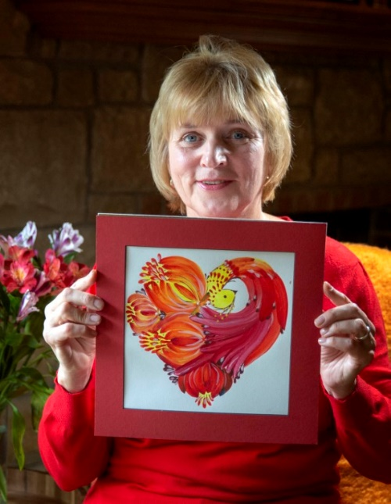
Lyuda Cameron was born in the Ukraine which as you may know was invaded by Russia on February 24, 2022. The world expected the Ukrainian people to be crushed within months of Putin’s large-scale invasion. Instead, we have watched in amazement as the Ukrainian people fight valiantly to save Democracy. At first Lyuda, who has lived in the United States for over 18 years, sent money, but realized her donations alone were not enough to help the depressed citizens and soldiers who are dying. So, she began to share their stories and the artwork painted by children and teens who remain in the Ukraine. In addition, she holds workshops in Oklahoma to share the traditional painting style from her homeland.

Lyuda works 5 to 6 hours each day for the charity called “Sooner Hope”, that supports the Ukrainian people as they resist Russian’s invasion. With the money the small group of volunteers raise, they were able to recently send 240 sets of uniforms and 240 sets of thermal underwear to cloth every soldier in two battalions in the city where she was born. Lyuda said Sooner Hope only works with people they know to ensure the clothing and other donations go where intended. Lyuda does not keep any of the money raised. She says, “It all goes to save somebody’s life.”

The painting style Lyuda will demo and lead in the workshop is based on a unique one-stroke technique for painting which mixes two contrasting colors and uses special brushes made in the Ukraine. She will provide all the paint, special paper, and brushes needed in the workshop. Each flower, each bird, has significant meaning. The “birds of victory” are patriotic symbols signifying strength, beauty, and victory. The folk art, where animals are usually shown in profile and flowers head-on, is thought to protect the people from sorrow and evil by representing light, harmony, and happiness. Feelings we all can embrace. Through art, Lyuda is raising both awareness and money for Ukraine’s freedom.

The workshop for January 13, 2024 will be held from 2pm to 5pm and cost $30 for MDAG members and $40 for non-members. Sign up and pay at the January 8 meeting. If you need to sign up and pay before then, contact Kara Gardner at 405-317-7655. There is no extra charge for the facility as the space is being donated by Wickline United Methodist Church. The church hosted two of Lyuda’s workshops for their members (2022 and 2023). The church is located at 417 MidAmerica, Midwest City, OK 73110. Head north from I40 on South Air Depot Blvd, (between SE 29th and SE 15^{th)}, turn east on West Fairchild Ave. At the second stop light proceed into the south parking lot of the church. Enter the double doors under the portico, go straight and enter the last door on the left into Fellowship Hall.

When asked about the minimum number of people required to make the workshop, Lyuda, who is a new MDAG member, said the cause is so great, she will hold the workshop for one person if that is all who sign up.

Remember, Persons who sign-up for a workshop must pay the entire workshop fee by 9 PM at the preceding monthly meeting unless special arrangements are approved by the treasurer. Fees are nonrefundable unless class is cancelled. Individuals who are unable to attend may select a substitute to take their place at the workshop.

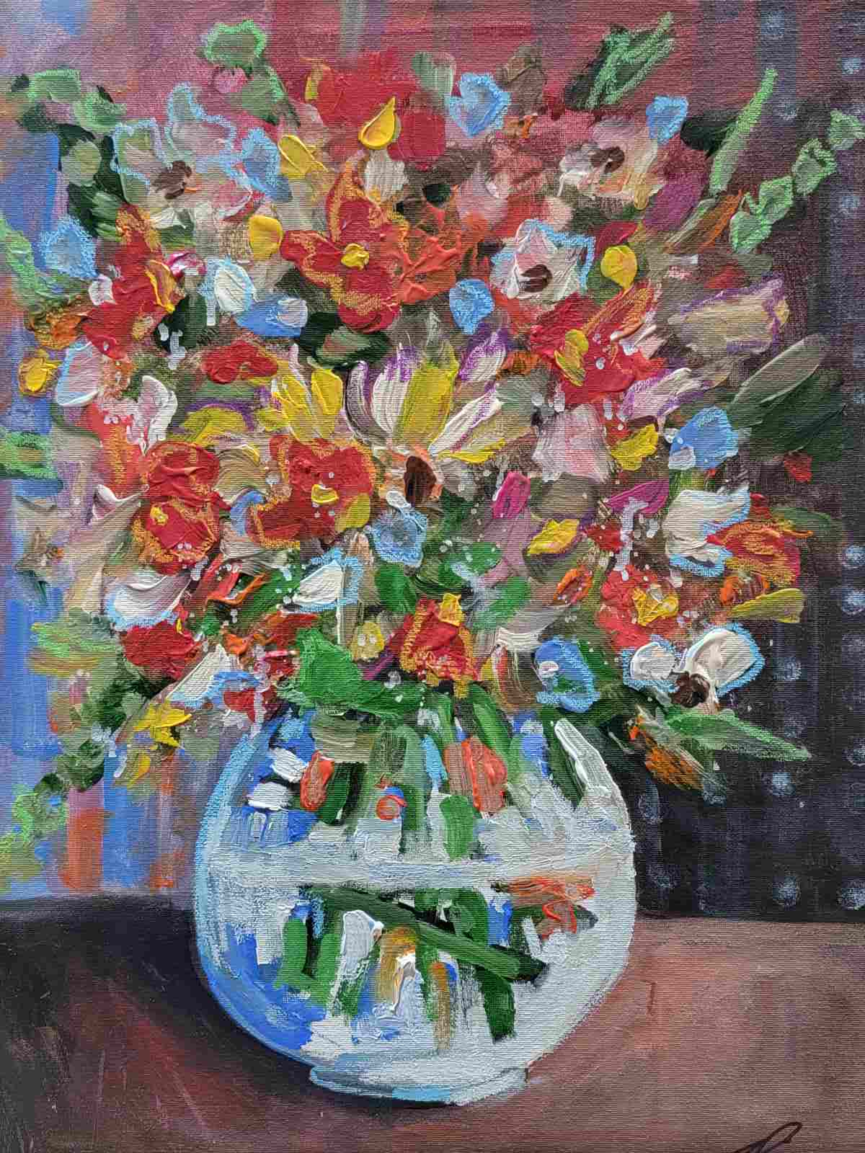
Thank You Jerry Piper for Nov 6 Demo

Jerry brought a number of his paintings to describe techniques he used. For instance, in a painting of a forest with the light peeking through between the trees, he used a small round “dauber” stamp with yellow and white to capture the light as it sometimes appears in photos. One watercolor painting was one of a series of 30 paintings named “Heaven and Nature Sings” which he sold successfully in his North Park Mall gallery. The series was inspired by having bought bargain priced mats at the Basket Market. That is the close- out store for Hobby Lobby. Jerry has been painting mostly in water colors recently which is a medium he fell in love with as a young man.

One of the pitfalls of new artists, he said, is overworking. Jerry challenged artists to see what can happen in 10 minutes when they paint spontaneously. Although Jerry uses bright colors he repeated a saying he uses in the classes he teaches, “color gets all the glory but values do all the work”. It is a reminder most of us need. The extremes of light and dark values are needed to grab the viewers’ attention.

For the demo Jerry recreated a painting of a glass vase with flowers that he won an award for. He is often asked how he paints transparent glass. He quickly completed the vase and then applied oil pastels to the previously painted acrylic flowers. The oil pastels added another dimension and a fresh lively look. Notice in the photo he intentionally did not trace along the edges of what he had previously painted. And he used complementary colors like purple next to yellow flowers to add to the excitement. One caution, the oil pastels do not dry and require the painting be varnished.

Jerry buys quarts of Rust-Oleum clear gloss sealer. Only once did he have a problem with the varnish smearing his purple acrylic paint. It is much cheaper than buying Liquitex so he just repainted the picture. Finding ways to save money on supplies is worth the challenge. He bought the large jars of Masters Touch paint on sale for $5 a jar. Kara Gardner added that she has found Masters Touch makes one of the better blacks (good to know). Jerry donated the demo painting for a door prize (won by Sandra Dossey) and two of the prints (won by Isabella Campos and Elisa Dewhirst). Additionally, Jerry gave up his $100 honorarium to renew his membership in the MDAG.

We now have 41 paid members. Twenty-six people attended Jerry’s demo. Jerry will talk more another time about an opportunity available for the guild to exhibit juried work at the North Gallery and Studio in 2024. And for those interested in taking Jerry’s classes, he teaches water color from 10 to noon and acrylics from 1 to 3 each Thursday at a church near Hefner and May Avenue in OKC. You can reach Jerry at 405-249-5499 for more info.

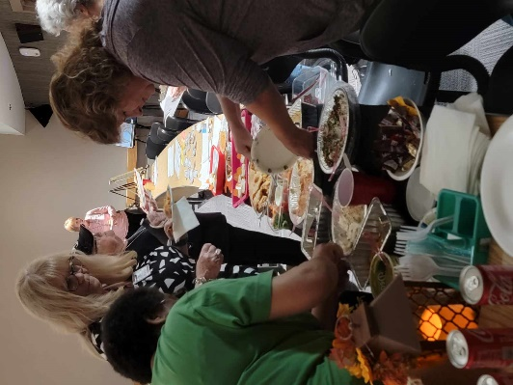
Thanks for the Goodies!

It worked well to have our snacks around 8pm which gave us time to socialize, vote, and buy raffle tickets. We had plenty of goodies, like dips, chips, cupcakes, sodas, water, and my favorite, an apple pie from Costco. It was the biggest pie this writer has ever seen and Margee said it only cost $13. Thanksgiving is coming. I have given up buying frozen pies as the crusts are awful and the apples are hard and tasteless. This pie was perfect. Thanks to Margee Gaeddert, Sandra Dossey, and Karen Dickerson for the fine fixings. And we appreciate all the members who have already signed up for 2024.

Welcome Your New Slate of Volunteers for 2024:

Executive Board:
President – Joan Faught
1st VP Show Chair – Marilyn Ragan
2st VP Program Chair – Susan Schmidt
Treasurer – Kara Gardner
Secretary – Cindy Van Kley
Member at Large - Mary Jude Delaney
Newsletter – Vacant [Susan Schmidt can continue until someone volunteers to take over].

Appointed Positions:
Parliamentarian – Cindy Van Kley
Hospitality – Karen Dickerson
Hang Around town – Sandra Patterson
Greeter – Dana Masters
Webmaster – Arelia Rocker
Social Media - Marilyn Ragan

Note: Volunteering for newsletter co-editor(s) would be a great opportunity to apprentice for the job by reviewing draft newsletters and writing several articles. Learn more about editing photos and using Microsoft Word over Zoom. If interested email Susan Schmidt at sbschmidt88@sbcglobal.net.
MDAG Contest Winners
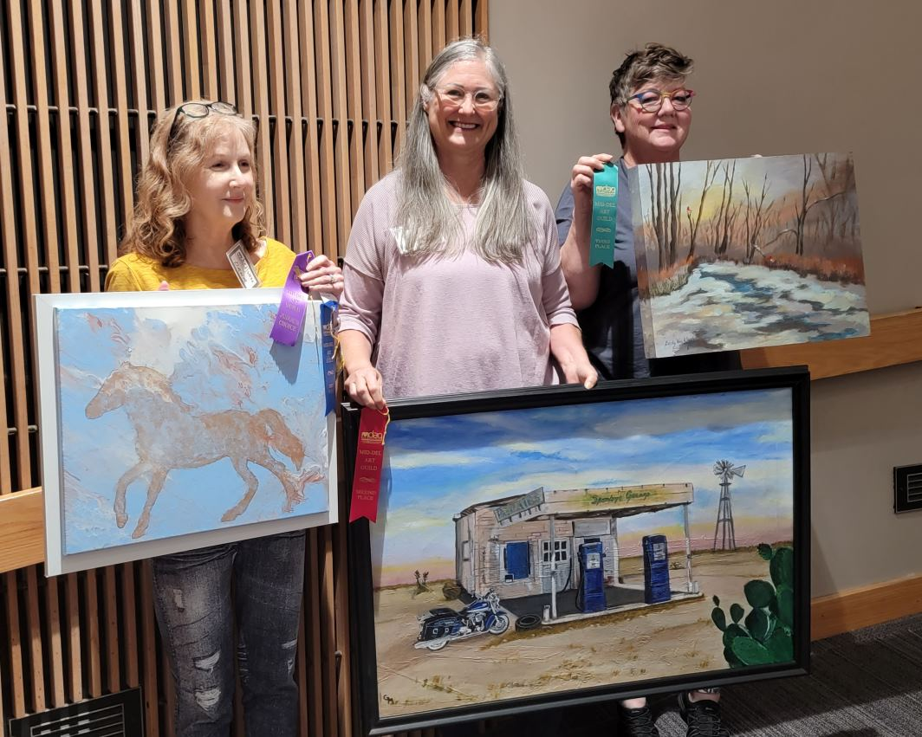
The November member contest winners were:

Dana Masters, 1st place for acrylic pour with sponge details “Galloping to New Mexico”,

Georgia Myers, 2nd place for her acrylic “Sparky’s Garage”

and Cindy Van Kley, 3rd place for acrylic “Winter Visitors”.

New Member Gerald Hudson won the Judges choice for his first painting ever! Sorry we missed getting your photo. Congrats All! There were at least 9 paintings in the competition, the most of any meeting in 2023.

Winners’ Show Opportunities

There will be a show of all the 2023 winners at the MWC Library from January 2 through 31. Winners can hang their winning pieces and/or bring other works to fill-in. Set-up from 3pm to 5pm on January 2 would allow the most coordination among artists for space with Marilyn Regan and the last artists making final adjustments to make the space look good. Marilyn Ragan (405-412-0837) is the 2024 First VP and is in charge of shows. Remember you can’t sell your pieces at the library but you can include your contact info, and maybe win “Best of Show”.

All members of MDAG are invited to reserve the library wall for an individual or group show. As of this writing, the wall and presumably cases are available from February through December 2024. Drop into the MWC Library to make a reservation or call 405-606-3436.

And don’t forget to sign up for Hangin’ Around Town at monthly meetings. Consider visiting those businesses to see what your friends are exhibiting. While there buy a tv, fill a prescription, or get your dog fixed. Duke or Daisey might want some input on that last idea.
Midwest City Elementary School Mural Project

Staff at Midwest City Elementary (MCE) school requested MDAG paint a mural for the cafeteria stage. Much more was completed. The kids and staff voted on an inspirational quote to aid in the design. The winning quote is "You are loved and important, you bring to this world what no one else can.” MDAG members advanced hundreds of dollars to purchase supplies to keep the project on schedule. The Midwest City Beacon interviewed several people and took photos of the mural’s progress. The mural and some of the volunteers were featured in the October 25th issue under title “Artist come together to create mural at school”. Cindy reported the kids still need to add their fingerprints, the stage portion needs varnished, and the last wall is waiting on volunteers. If you would like to volunteer to help paint the final wall, the winter school break is December 16 thru Jan 2, 2024. Contact Cindy to volunteer and be prepared to paint from a tall ladder. The school address is 2211 Midwest Blvd, MWC 73110. Call Cindy Van Kley at 405-630-4504.

We hope Madeline will share with members her mural creation tips such as the software she used to generate the design, other software she used to estimate the amount of paint needed, how she projected the design on the walls, and show a timelapse video of the mural as it progressed from white walls to finished murals. It is an amazing mural which you can see more of on Facebook. Madeline is scheduled to share her secrets at the February 5th meeting so hold the date.
Scholarships To Attract Younger Members to MDAG
Margee Gaeddert has stepped forward to establish a Scholarship Fund to attract younger members to the guild. She will start by working with her nephew who is a professor at Rose State College to get candidate recommendations from the art department. We could award 5 scholarships starting in January 2024 for just $100. When a guest artist donates their honorarium that could go to the scholarship fund. And members like yourselves might want to donate $20 or more to elevate a young persons’ art exposure and aspirations by becoming a MDAG member. It would be neat if the students knew each other and might come together to our meetings. You know what they say about achieving your exercise goals? It is easier if you exercise with a buddy. The details are still being worked out but if you want to donate or volunteer to help or nominate a student, contact Margee at margee.gaeddert@gmail.com.
Margee will travel to Tulsa soon to demonstrate Digital Art using a software program called “Procreate” on her Apple iPad using an Apple Pencil. She plans to repeat the program for us on April 1. Urban Sketchers, a group in OKC who draw Plein Aire are also interested. Margee will also work with attendees who don’t know what they have or who need alternative software for Android devices, or a cheaper pencil in preparation for the April 6, 2024 FREE workshop.
Margee says the methods she uses to paint on a tablet are the same as traditional painting. For instance, she paints in pastels on the tables. I can’t imagine how that feels to paint a stroke of pastel color using a stylus. She says people are intrigued when they see her demo digital art which she has been doing for 10 years. The time has come for more people to give digital a try. And what better time than when we are serious about attracting younger members? We each have our mediums we are most comfortable using but it doesn’t hurt to be exposed to other forms of art. See how we can apply what we see to make MDAG more inclusive and our art style more contemporary.

SCHEDULED EVENTS
December 4 – Holiday Party - Restaurant Olive Garden at 5915 SE 15th St, MWC
January 2 thru 31 – 2023 MDAG Winners Exhibit – MWC Library Wall
January 8 – Lyuda Cameron Demo - “Painting for Peace”
January 13 – Lyuda Cameron Workshop - “Painting for Peace” at Wickline United Methodist Church at 417 MidAmerica, MWC
February 5 – Demo: Madeline Dilner “Creating Murals”
March 4 – Demo: Sheila Minnich “Colored Pencils”
April 1 – Demo: Margee Gaeddert “ Digital Art Using Procreate and Other Software”
April 6 – FREE Workshop: Margee Gaeddert “Discover Painting Traditional Mediums Digitally” at the Midwest City Library 1 to 4pm.

Dues are Near Due

Because the bylaws were amended in August, members get the last three-months of 2023 dues-free as the new year will start January 2024. Membership dues remain $35 and can be paid at the Holiday Party or at the January 8th meeting. Cut out the app below and when your friends or acquaintances act interested in joining, hand them the app. Let’s attract new members and get our friends to renew. It is more fun when we share our passion for art.
Join Mid-Del Art Guild
Membership
type: q Single/$35 q Student*/$20 q Family**/$40 q Business/$40
qNew
qRenewal Referred by:____________________________________________________

Date:_________________ Favorite Medium(s):________________________________

Name(s): __________________________________________________________________

Address___________________________________________________________________

City_______________________________ State_______ Zip________________________

PHONE: Home__________________________ Cell______________________________

E-Mail (for newsletter) _______________________________________________________
*Must be enrolled full time as Art Major, with current Student ID, or aged under 19 yrs old
**Two family members residing in the same household

Make checks payable to: Mid-Del Art Guild
Mail to: Kara Gardner, Treas. • PO Box 10393 • Midwest City, OK 73140

Hope you have great holidays and stay safe.
Susan Schmidt, Newsletter Editor
FILE: ART/MDAG/ Nov Dec 2023 MDAG News 110923 Lyuda Cameron.docx and pdf

