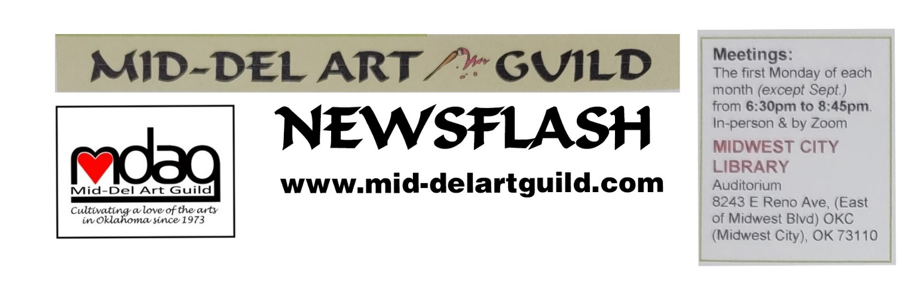 February 2024 Newsflash

Madeline Dillner
“A Mural from Start to Finish”
Guest Artist Demo 6:30 pm Monday Feb 5, 2024, at MWC Library

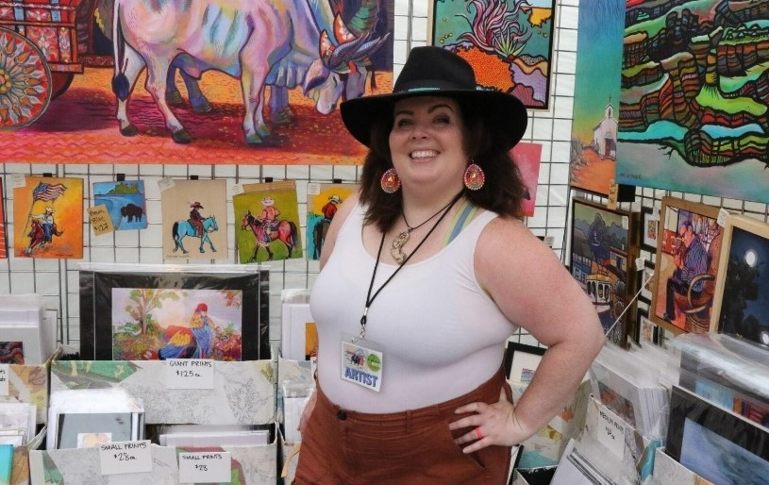
Madeline Dillner photo by Doug Hill, Norman Transcript
Recently, the Mid-Del Art Guild teamed up with the Midwest City Elementary School to complete a giant colorful mural in their cafeteria. Madeline Dillner, former MDAG President, designed this mural and managed its execution. Clocking in at nearly 300 people-hours, this mural was quite the achievement! Join the MDAG as we learn from Madeline about how to go about completing a mural of this -- or any scale -- from the design phase to the final touches.

Madeline was born 4 weeks early in Urbana, Illinois, and says “It is for this reason I am now late to most events” to keep the universe in balance. If Madeline is late, it is because she is trying to squeeze in as many adventures as humanly possible. Her quest for adventure started in her youth.
​
“I started drawing when I was very small, and somewhere I have a picture of a humpback whale that I drew on a manila envelope when I was 3. When I was 6, we moved to Winnebago, IL. We had a lovely home with a sand pit that my younger sister and I would use for wild desert adventures with our plastic Disney characters and a basement we could rollerblade around in.

At night we would watch Muzzy and Rick Steves while dreaming of Paris. In the summer of 2006, my parents and sister and I finally visited Europe–5 weeks in a RV! Germany, Luxembourg, Belgium, France, England, Scotland, Ireland, Wales, and Switzerland. It was 95 degrees and wonderful and stressful and beautiful and surreal and everything I’d hoped for. I graduated high school in 2008 having never taken an art class, but the margins of all my notebooks were filled with sketches.
​
I attended the University of Oklahoma from 2008 to 2013, where I majored in Environmental Engineering... then Political Science... then Mathematics... then Math Education... and finally, Environmental Sustainability. After 5 years in school, I earned my Bachelor of Science and started work as a temp for the State of Oklahoma (Oklahoma Corporation Commission)--georeferencing historical aerial photos. I still work for the OCC today, only now in a full-time position as the Brownfield Program Project Coordinator. I am an artist with a day job, and I love it.

I started painting in 2016, after 26 years of studying and working in non-art fields. As you may guess from my loudly-colored canvases, peace and stability have never been attractive to my brain. I prefer their rowdier cousins–elation and excitement. To me, the world feels muted until the roar of a concert or a new tattoo or my first view of the Rocky Mountains or winning an award lights up my brain with electric pink sparks.”

To see what Madeline is talking about follow the links to her website (https://www.madworldart.com), Instagram (https://www.instagram.com/maddoesthings), and Facebook (https://www.facebook.com/maddoesthings).

Consider Becoming a Mural Artist
The Normal Arts Council is assembling a Pre-Qualified Mural Artist Pool. Applications are due February 29, 2024 (https://normanarts.submittable.com/submit/283193/pre-qualified-mural-artist-pool. The Norman Arts Council’s Public Arts Committee with funding from the City of Norman, is launching a Mural Incentive program for businesses and commercial property owners in Norman, Oklahoma. Through an application process, the NAC will consider requests for funds of up to $10,000 for mural projects in the City of Norman. To connect businesses and property owners with muralists, the NAC is inviting muralists from Oklahoma to submit their portfolios and a statement that describes their mural style and technique.
Businesses may opt not to use one of the pre-qualified artists, or they may ask the NAC to assist in a selection process. The process normally begins with a review of the pre-qualified pool and a short list of appropriate artists for a specific project. It appears that if you have ideas and business contacts, you can bypass the pool step. Businesses who apply for the Mural Incentive program must agree to pay artists a minimum of $25/square foot for a mural commission.
Attending Madeline Dillner’s detailed review of the process in designing and executing the school cafeteria mural is a good start in deciding if you want to paint murals or if you just want to paint larger canvases. And although many of the MDAG Members and school staff who participated in creating the mural chose to work on high ladders, some artists want to keep their feet on the ground and only create murals inside homes. You pick.

To gain more insight into what mural designs you may want to pursue, Google murals. And be sure to check out the mural town of Lake Placid, Florida, where Susan Schmidt visited. Lake Placid was named “America’s Most Interesting Town” by Reader’s Digest and is famous for mural themes related to historical, cultural and environmental events in central Florida. See some of the innovative ideas they implemented like including sounds (cattle hollering and trains blaring). They encourage viewers to look for hidden things in each mural. The Lake Placid Mural Society makes sure the murals are resealed every few years and that the original artist has the opportunity to repaint the murals when needed (some murals have been repainted five times to keep them looking fresh). They also sell a booklet with the story of each mural, its location, artist, etc. You can see the murals at www.muralsoflakeplacid.com .

Final Touches Added to Last Day of Painting Mural
at MWC Elementary School

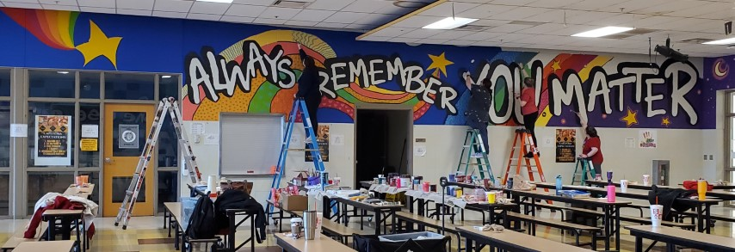

The last wall was painted on Saturday Jan 13th. Cindy Van Kley and Madeline Dillner from MDAG coordinated and painted along with several school staff members to complete the South wall of the cafeteria.

Guild president Joan Faught assisted by bringing coffee and cinnamon rolls to fortify the artists! This was a huge project. Thanks to all who contributed over the past few months.

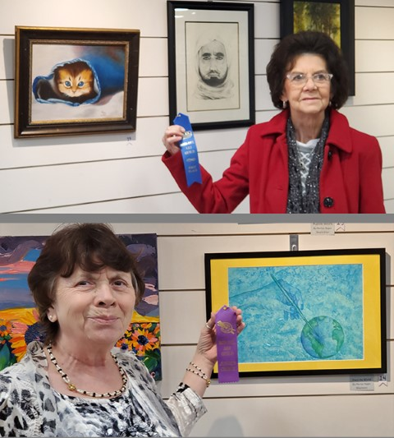
2023 MDAG Winners Exhibit at Library & Announce Overall Winners

June Rea won Patrons Choice and Marilyn Regan won Judge's Choice for the MWC Library show.

Congratulations! All participants were winners of ribbons in 2023 MDAG meetings, so our 2 award winners were voted “Best of the Best”, technically speaking.

Thanks to all artists who participate in the monthly contests and to those who helped set up the display. Great opportunity to increase the MDAG’s visibility in the community by having our work in the library lobby for all to see! It encourages children and adults alike to better appreciate art.

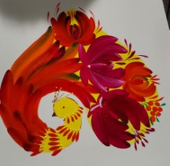
Thanks to Guest Artist Lyuda Cameron
By Cindy Van Kley

Lyuda Cameron from Ukraine has been a Mid-Del Art Guild member for many months now. Her organization is called Sooner Hope for Ukraine, which raises funds to support civilian defenders of Ukraine.

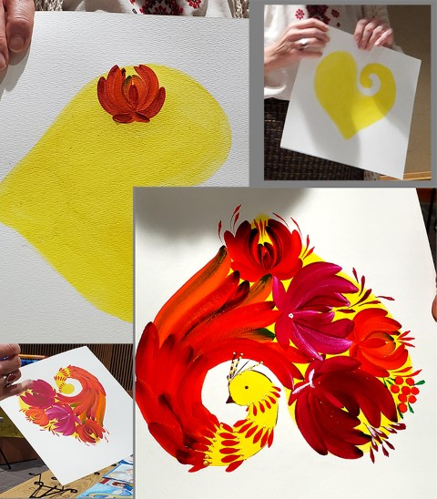
The Ukrainian folk-art technique Lyuda demonstrated uses a very old style called Petrykivka, named for the town where it originated. Women with no paint brushes created a way to paint using flower, berry, earth, and vegetable juices (like beets, carrots, onions, etc) and using little sticks to paint.

They eventually started creating brushes using cat fur, because of its easy availability. Lyuda even made some brushes using rabbit fur.

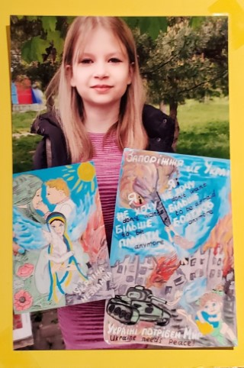
She created the above design because she likes red as a color of victory and happiness. The bird represents luck and victory. The heart symbolizes your heart. Any way you turn this design it is still a heart. In Ukraine, there is not much variety of vegetables available, so most of the flowers you see painted are basically onions. One rule in Ukrainian folk art is that it is only 2 dimensional, so no shadows. She paints in gouache, a water-based medium which dries pretty fast. She decided to make small, medium and large onions on this piece, and used red plus green (its complement) for the darker areas.

Asked about Sooner Hope, Lyuda said that they help military, civilians, and children. “We buy clothes and hats and gloves, and make tourniquets as well as kits for wounds and bleeding.” The children they help wanted to help the cause and they started painting. Lyuda made cards from all the paintings. She has around 70 pieces of art in her gallery. She only sells the prints, not the original artwork. Lyuda handed out the postcards with QR code (see below) to an online gallery of the children’s artwork.

Most of the fighters in Ukraine are just citizens, not trained military people. They are defending their right for their culture, language, and country to exist. Her organization works from a list of what is needed which she gets from her friends still living there. Her sister was in Ukraine, and she lost her house in the war. She is now a 3-time-refugee. Not all people leave the country because of the fighting. Many have stayed to help, despite their personal hardships. Every day for TWO YEARS there has been shelling. All wars are connected to people who want power.

There is a movie about Ukraine that is showing in some theaters called “Glory to Heroes” by French philosopher and journalist Bernard Henri Levi. It is 1½ hours long and covers June of 2023.
Another film you may want to find is “Mavka: The Forest Song” about the soul of the forest. It is animated, and released in 2023 streaming on hulu. IMDB says, “Mavka must choose between love and duty to protect the Heart of the Forest.” Nature and its well-being play a significant role in the story. It is based on a drama, “The Forest Song” by Lesya Ukrainka, as well as on the images of Slavic mythology. It is said to have “authentic Ukrainian charm.”

Every month Lyuda produces a newsletter reporting how much money has been raised, what all was purchased and sent to Ukraine, and some pictures she has received back. She does this because she has to be accountable to have her non-profit status. She encouraged us to continue donating if possible, and to share their Facebook page and website with our friends. For more info, the postcard with the QR code will allow you to see the children's artwork gallery.

Members’ Choice ribbon winners at the January meeting were:

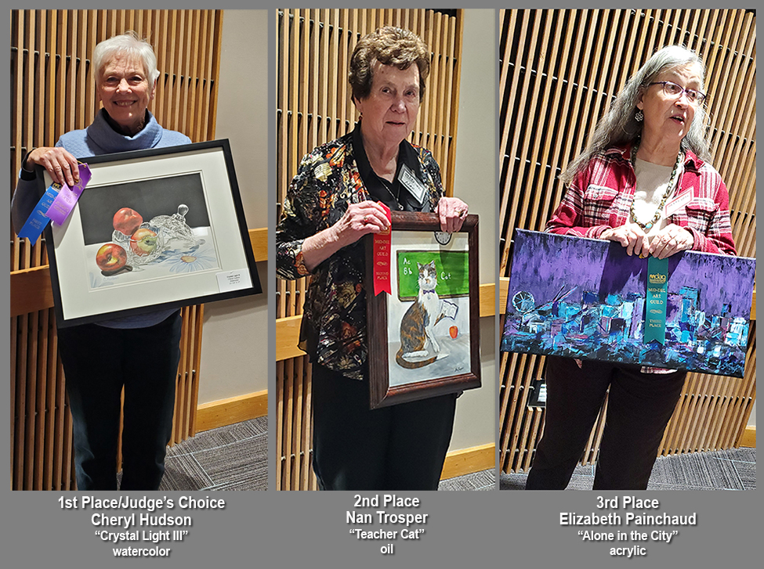

Candis Frederickson was the Door Prize winner. She received an art pack which included canvas and brushes.

MDAG Officers and Appointed Positions for 2024:

Executive Board:
President – Joan Faught
1st VP Show Chair – Marilyn Ragan
2st VP Program Chair – Susan Schmidt
Treasurer – Kara Gardner
Secretary – Cindy Van Kley
Member at Large - Mary Jude Delaney
Newsletter – Vacant [Susan Schmidt can continue until someone volunteers to take over].

Appointed Positions:
Parliamentarian – Cindy Van Kley
Hospitality – Karen Dickerson
Hang Around town – Sandra Patterson (Get well wishes to Sandra who broke her wrist recently)
Greeter – Dana Masters
Webmaster – Arelia Rocker
Social Media - Marilyn Ragan

SCHEDULED EVENTS
(all events shown are in the MWC Library Auditorium)

February 5 – MDAG Board meeting 5:15 pm.
February 5 – Demo: Madeline Dillner “A Mural from Start to Finish” 6:30 pm

March 4 – MDAG Board meeting 5:15 pm.
March 4 – Demo: Sheila Minnich “Colored Pencils” 6:30 pm.
April 1 – MDAG Board meeting 5:15 pm.
April 1 – Demo: Margee Gaeddert “ Digital Art Using Procreate and Other Software”6:30 pm.
April 6 – FREE Workshop: Margee Gaeddert “Discover Painting Traditional Mediums Digitally” 1- 4pm.

Renew Your Membership for 2024

The member year now runs January 1 through December 31. We want to see you and share our passion for art together. Renew your membership if you haven’t done so yet. You can pay at the next meeting. Or copy the app and mail to Kara Gardner at address below. And consider sharing an app with an interested artists to build our guild. We all know someone else who loves to dabble or who paints passionately! Please remember to hand out our black MDAG business cards wherever you meet or interact with other artists. You can pick cards up at the next meeting. Life is more fun together.

Join Mid-Del Art Guild
Membership
type: q Single/$35 q Student*/$20 q Family**/$40 q Business/$40
qNew
qRenewal Referred by:____________________________________________________

Date:_________________ Favorite Medium(s):________________________________

Name(s): __________________________________________________________________

Address___________________________________________________________________

City_______________________________ State_______ Zip________________________

PHONE: Home__________________________ Cell______________________________

E-Mail (for newsletter) _______________________________________________________
*Must be enrolled full time as Art Major, with current Student ID, or aged under 19 yrs old
**Two family members residing in the same household

Make checks payable to: Mid-Del Art Guild
Mail to: Kara Gardner, Treas. • PO Box 10393 • Midwest City, OK 73140

Susan Schmidt, Newsletter Editor

